**HTML attributes –**

**What are the Html attributes which are used in html document?**

**HTML attributes** is a concept of providing extra Features to the html elements. In html document, All the HTML elements may have attributes. Attributes is an additional information or characteristics provided to the html elements like providing width and height in an image tag, providing color or font style to the name tag etc. Html Attributes are always defined under start tag or Opening Tag. Attribute consist of name/value like pairs such as name=”value”. some tags like <img> image tag or <a> anchor tag must contain attributes. In <img> tag must contain src and alt attributes.

**Examples of HTML attributes are given below –**

|  |
| --- |
| <img src="D:\html\images\nature.png" width="700" height="500" > |
| <a href=example.com>click here to go on link</a> |
| <body background="D:\html\images\nature.png"> |
| <table width="50%" border="1" bordercolour="black" cellpacing="2" cellpadding="2"> |
| <font size="3" color="white"> |
| <input type=”text” Value = ”harshada” > |

**Above Examples Explain here-**

In the above example, <img> image tag consists of src attribute with width and height. Where src specifies the location or path of the particular image where your image has been saved in your local computer.

In second example, <a> anchor tag refers to the hyperlink, which is use for link one web page to another web page. <a> anchor tag must have href attribute. In which href is an attribute which specifies the URL of the web page.

**What is the href Attribute in HTML document?**

In HTML document, href is an attribute which helps to specify the URL. In href we need to mention particular link of web page which will helps to indicate links destination. By using this href attribute you can navigate from one web page to another web page.

**For Example-**

<!DOCTYPE html>

<html>

<head>

<title>link tag</title>

</head>

<body>

<a href=www.google.com>click here</a>

</body>

</html>

**Output –**

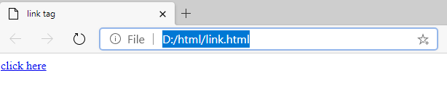

**What is the Title Attribute in HTML document?**

In HTML document, if you want to give title for your document then <title> tag is used. This title is shown in the browser’s title or page’s tab. Web Browser then display your page title on mouseover.

**For Example-**

<!DOCTYPE html>

<html>

<head>

<title>style tag</title>

</head>

</html>

**Output-**

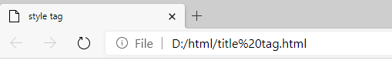

**What is the src Attribute in HTML document-**

The src attribute is an important attribute in image tag. Src is a source where src specifies the location or path of the particular image where your image has been saved in your local computer.

**For Example-**

<head>

<title>image tag</title>

</head>

<body>

<img src="D:\html\images\nature.png" width="700" height="500" >

</body>

</html**>**

**Output-**



**What is the style Attribute in HTML document –**

In your HTML document style attribute is used to provide extra features or characteristics to your web page so that the content which you mention in your HTML Document will look more attractive.

**For Example-**

<!DOCTYPE html>

<html>

<head>

<title>style tag</title>

</head>

<body>

<p style="color:red;">My paragraph is in red colour</p>

</body>

</**html>**

**Output-**

